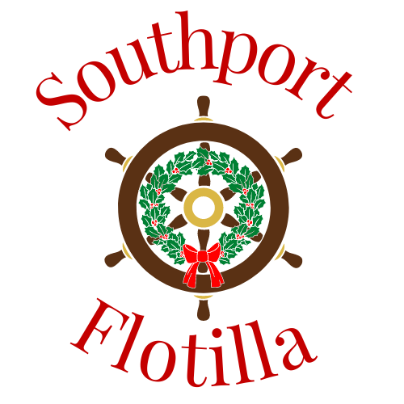

Welcome, and thank you, for being a part of the 2021 Southport Winterfest Flotilla. We hope this year will be an enjoyable experience for you so that you will consider making your participation a tradition in the future. We also want this to be a SAFE, incident free event for you and your fellow Flotilla members. We feel with an organized float plan, we can all enjoy a safe and fun event. Please take time to make sure you understand the information in this packet before leaving the captains’ meeting today so we can make things go as smoothly as possible during the event.

Please remember, we have a float plan in place and will attempt to execute it to the best of our ability, but there will be on-the-water decisions made to allow for the various river conditions and weather. Please be patient and do not get in a hurry at night.

SAFETY FIRST

Our goal is to have a joyous, festive occasion that is accident free and fun. Please keep in mind that the water temperature will be cold, and visibility will be limited at night. A person overboard has only minutes before being overcome by hypothermia. Please make sure all crew members take special precautions not to put themselves in danger of going overboard. Personal Flotation Devices (PFDs) are highly recommended for all crew and required for anyone less than 13 years of age. Please consider personal glow sticks or strobe lights and have man overboard (MOB) equipment handy and on deck. It is the captain’s responsibility to brief the crew.

If this is your first time participating in the Flotilla, please talk to one of the veterans here today about visibility. Visibility at night is generally poor. It is also greatly compounded by the fact that you will have numerous decorative lights on your vessel that will decrease your night vision and make the red and green lights of navigational aids extremely hard to spot. You should have a designated watch person in the forward area of your vessel to help you spot other vessels and navigational aids. This crewmember must be able to communicate freely with you.

The weather may not be great during this part of the year. We have had strong currents, wind, rain, fog, and cold weather. We have also had calm and generally warm weather with little wind or current. This year is anyone’s guess. We will plan for the worst and hope for the best. The Cape Fear River can surprise us either way. The US Coast Guard (USCG) will help us judge the weather conditions. The final weather decision will be made in coordination with the USCG. If the final decision is not to conduct the Flotilla, we will make the announcement as soon as possible. Even if the decision is to go ahead, each vessel Captain has the final call for their vessel. If you don’t feel comfortable with the conditions, DO NOT GO! If you experience engine difficulties before the callout, DO NOT GO! Others will enjoy the lights on your vessel as it remains in the harbor.

Remember, no fireworks are allowed!

All vessels and crew must adhere to USCG boating safety regulations, including those related to the consumption of alcohol. Please save the alcohol until after the vessel has returned to the berth and been secured.

JUDGING

Judges will be located on the west end of Waterfront Park (near Oliver’s Restaurant) on the bulkhead. One of the largest challenges for the judges is making sure we know which vessel the judges are judging. Identifying vessels at night is very difficult. For this reason, we will be assigning an order for you to follow in the Flotilla. Please make every effort to maintain that order. Pass only if the vessel ahead of you is having a serious problem making way or is dropping out of the Flotilla for some reason. Please notify the Cape Fear Yacht Club (CFYC) control on Channel 78 if your vessel drops out for any reason. The elementary school children and adult judges doing the judging need your assistance by staying in the correct order.

PARADE PROCEDURE
Times are approximate and will depend on river and weather conditions the night of the Flotilla.

- All vessels must monitor Coast Guard Channel 16.

- All vessels must also have a working VHF radio on channel 78. Channel 78 is the Flotilla operating channel for all directions and information. CFYC control will be communicating Flotilla directions on Channel 78.

- CFYC control will be on station and monitoring Channel 16 and 78 near the entrance to the Old Yacht Basin (Old American Fish Deck) at approximately 6:00 pm.

- The CFYC will begin the Flotilla parade lineup at 6:40 PM at the Flotilla Start Line in the Intra-coastal Waterway (ICW) near the entrance to the Old Yacht Basin (Provision Company / Old American Fish). The Flotilla parade route will be from the Old Yacht Basin Start Line past the Waterfront Park and City Pier to approximately half a mile past Kingsley Park area to marker 19. A mark boat will be in the general vicinity Marker 19 to define the turning point. It will have a white strobe light to identify it. The parade route will then circle back toward Waterfront Park and Old Yacht Basin staying more mid-channel to not interfere with vessels still passing the judging area.

- Vessel Staging:
  - The plan is to stage the vessels, but not create a difficult and demanding process. Vessels docked in the Old Yacht Basin will stage in the Old Yacht Basin and be ready to join the Flotilla at approximately 6:45 PM.

  - Vessels from Southport Marina, Indigo Marina, South Harbor Marina, St James Marina, Bald Head Island Marina and other individual vessels must time their arrival to be at the Flotilla Start Line at approximately 6:40 PM.

  - Once in the vicinity of the Start Line, all vessels should check-in with CFYC control on channel 78. Vessels will be instructed to begin staging behind each other in a circular counterclockwise cruising pattern between the Start Line and Southport Marina.

  - If we have commercial fishing vessels, they will lead the Flotilla, followed by power and sailing vessels. If no commercial vessels participate, power vessels will be staged in line first followed by the sailing vessels. Kayaks, canoes, and rowboats will stage in the vicinity of the entrance of the Old Yacht Basin and the Intra-coastal waterway. Special instructions will be issued to them on an individual basis.

  - As vessels arrive in the staging area, CFYC control will provide directions and Flotilla position to each vessel on Channel 78. Please follow the instructions and maintain your assigned position. The ICW will get crowded and vessel control will be important. The Bald Head Island (BHI) Ferry operating between Deep Point Marina and BHI may pass through the Flotilla between the City Pier and Kingsley Park area. Please be on extra alert for the BHI Ferry in that area. The wake is significant if they do not reduce speed.

  - At 7:00 PM the lead vessel of the Flotilla will be given the “GO” signal to start the Flotilla parade. This year the “GO” signal will again be the firing shot of the Southport Historical Society’s Cannon “THOR”. “THOR” will be located on the Garrison lawn. The cannon firing will also be announced on Channel 78. The lead vessel (USCG) or Cape Point will set the pace to accommodate the slowest vessels in the parade based on current and wind conditions.

  - Once the Flotilla begins, the plan is for all vessels in the Flotilla to stay on the North Side of the ICW, the port side of your vessel as you approach Southport and Waterfront Park to allow our judges the best view of the vessels.

- Please leave the area in assigned order and make every effort to keep approximately 100 feet to 200 feet between vessels. All parade vessels must maintain the in-line, bow-to-stern formation. If you drop out or pass a vessel for any reason, inform the CFYC control boat on Channel 78. The judges must know your Flotilla location to insure they are judging the correct vessel.

- Please follow and complete the course. In all publicity for the Flotilla, spectators have been offered the areas from the Old Yacht Basin to Kingsley Street to watch the Flotilla, so please cruise the entire route and help our spectators have an enjoyable experience.

A special thanks to all participating Flotilla Captains and crew for making this year’s Flotilla a part of Southport’s historic waterfront heritage!

The 2021 Flotilla Committee

